EXPERIMENT 7

DQL COMMANDS (COLLEGE SCHEMA)

Aim:

Display student id and marks from the student table.

Display faculty id and name from the faculty table.

Display who got grade A.

Display whose marks are less than 50.

Display the female students whose marks are between 50 to 60.

Delete the failed students.

Display activity id and name using object.

Display student id, faculty id using course name condition with object.

Select department name starting from ‘c’ and faculty name ending with ‘ ’.

Select activity having characters between ‘ck’.

Group by faculty id and display.

Display the students list whose grade is A using having.

Display the faculty list who are teaching PPS.

Apply aggregate functions in student marks - max, min, sum, count, avg.

**QUERIES:**

Display student no,marks from student table.

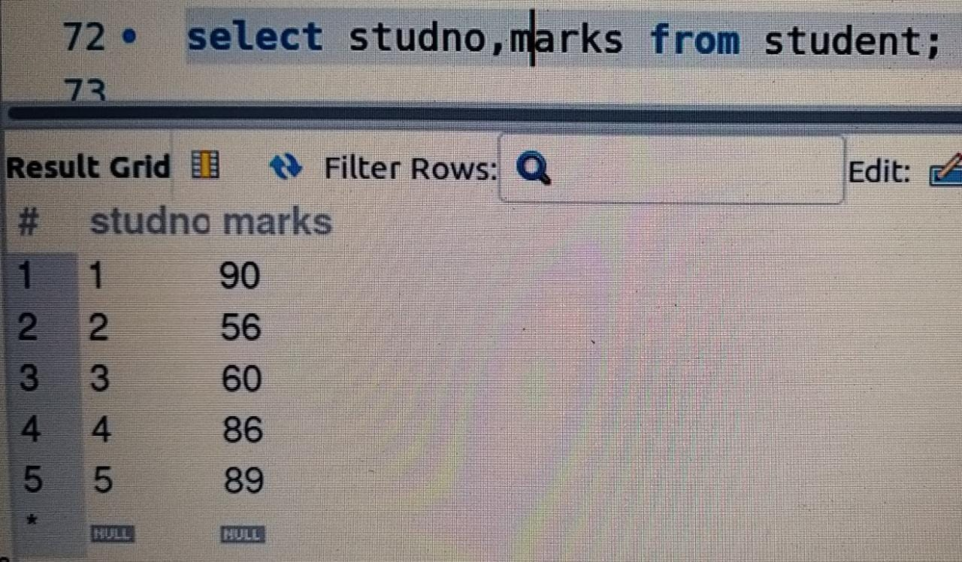

Display faculty no,name from faculty table.

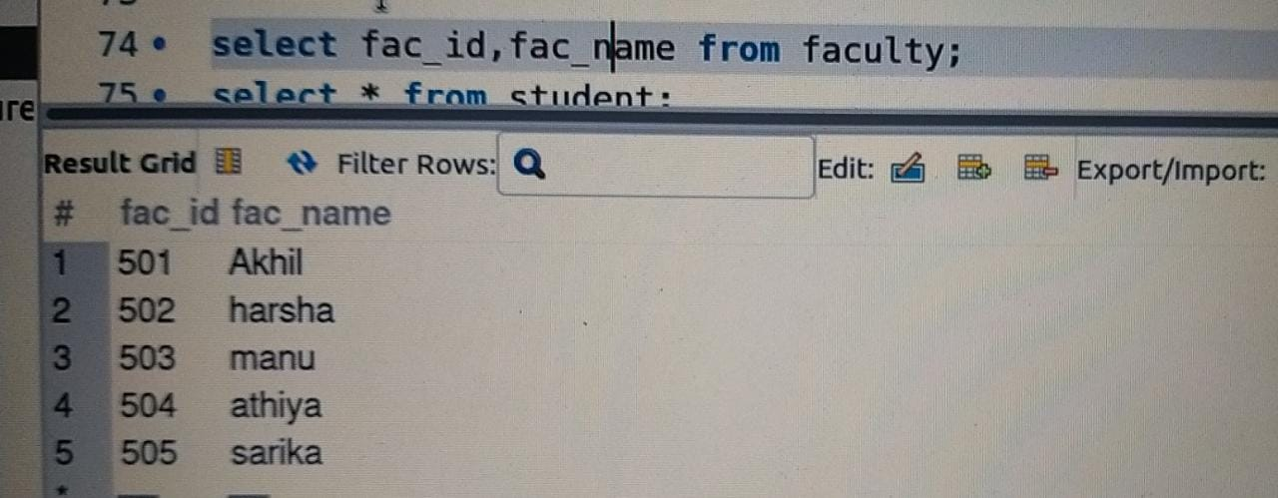Display who got grade A.

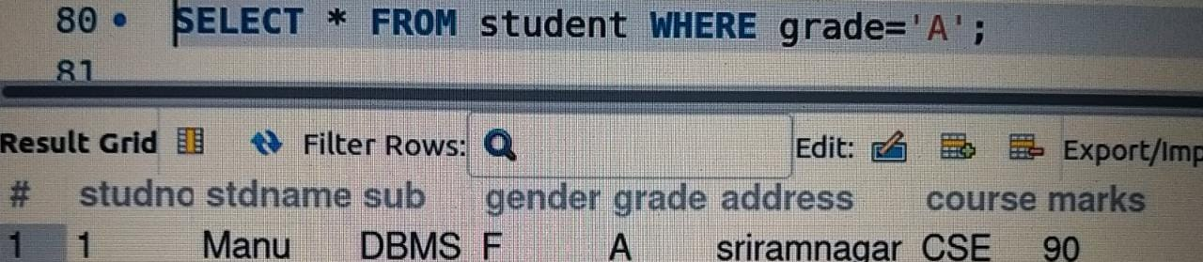 Display whose marks is less than 50.

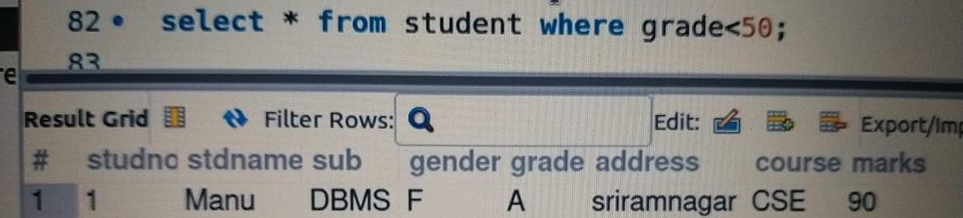

Display the student id and name whose mark is 50 to 60 and female.

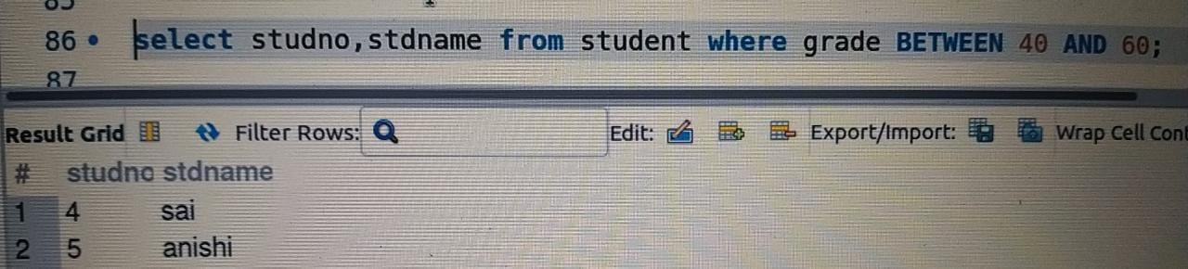Delete the failed students.

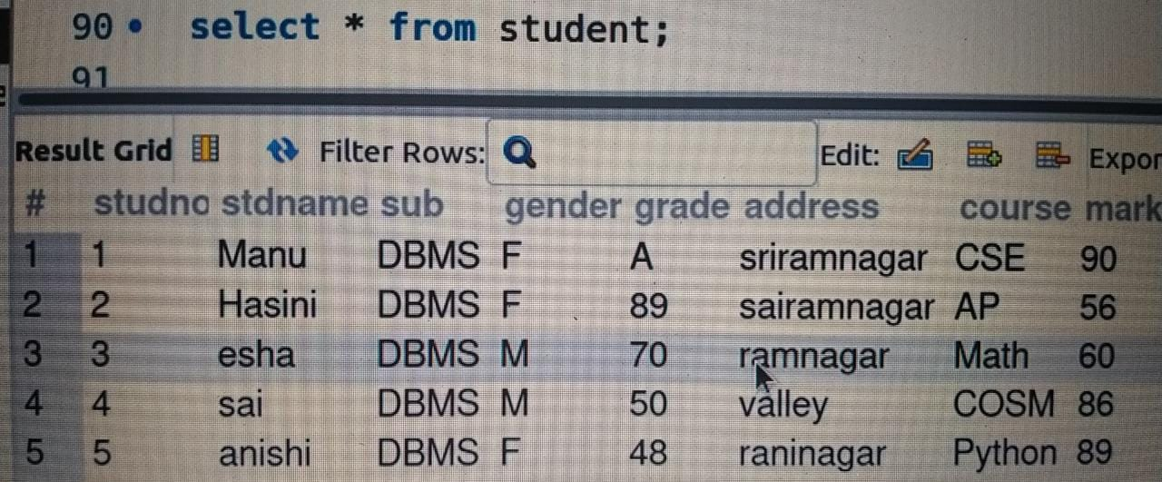

Display student id, faculty id using course name condition with object.

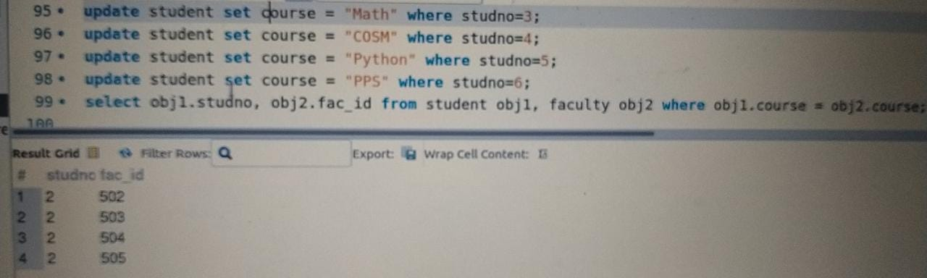

Select department name starting from ‘c’ and faculty name ending with ‘ ’.

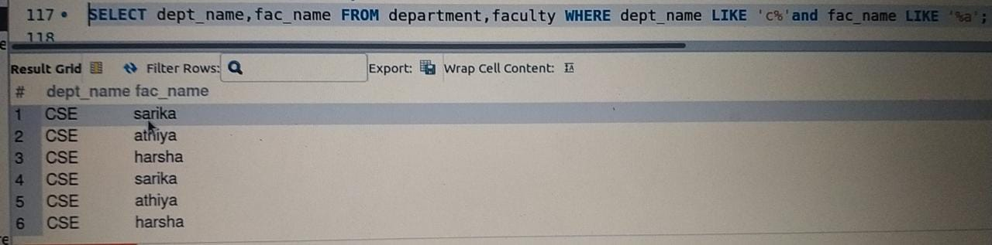

Select activity having characters between ‘es’.

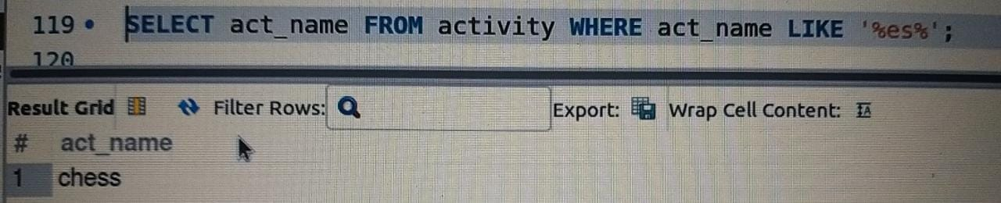Group by faculty id and display.

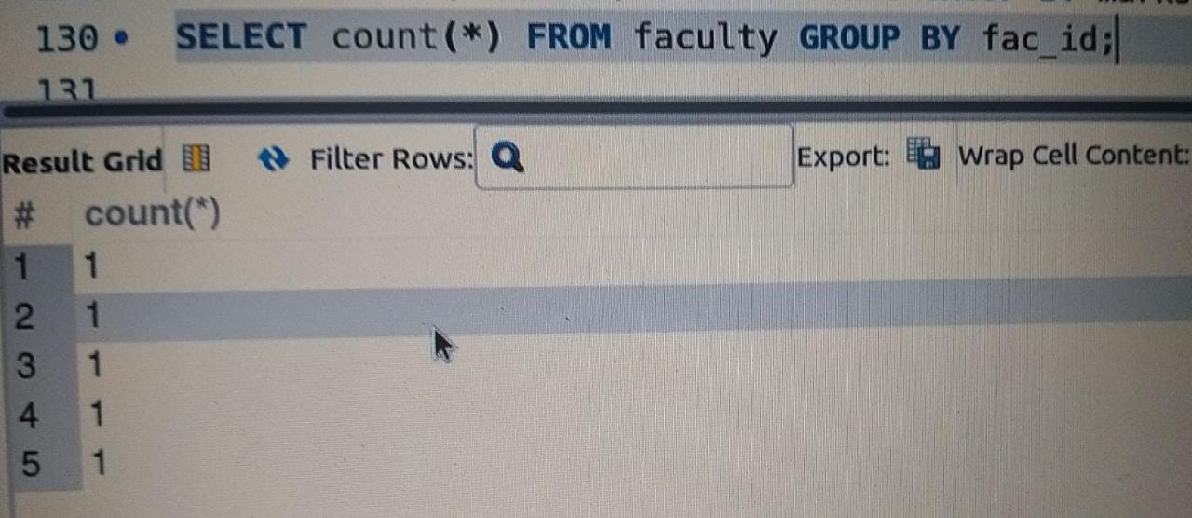

Display the students list whose grade is A using having



Display the faculty list who are teaching subjest pps

Apply aggregate functions in students marks-min,max,sum,count,avg

